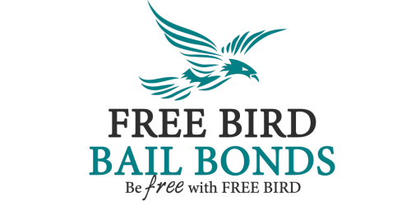Promissory Note
For Your Information and Protection:
______ Free Bird Bail Bonds and their agents are required by state law to collect no less than 10% (and no more than 15%) of the bond amount regardless of the client’s case status. Free Bird Bail Bonds makes every reasonable attempt to collect outstanding debt to uphold the criteria of our bail bondsman license issued by the state of Virginia Department of Justice and Criminal Services.
______ The money owed by signing this promissory note is without interest. Free Bird Bail Bonds and their agents operate with the highest standards and compliance to professional regulation. Charging interest on money owed for a partial or completely financed bail bond is against the law.

I (We), individually and separately, promise to pay the amount of: $__________, (_____________________________________________) dollars to Free Bird Bail Bonds.
This debt reflects the outstanding balance of the bail bond issued by Free Bird Bail Bonds for:
________________________________________________________________ (Bail Bond Client), in
___________________________________________ (Arresting Jurisdiction(s)) for the original sum of,
$______________________ Dollars on this date: _______________________.
Payment Notes, including payment schedule/deadline if any:

Signature ____________________________ SS#_______________________ Date __________

Signature ____________________________ SS#_______________________ Date __________
OFFICE USE ONLY
PAID IN FULL ____ DATE _____ BONDSMAN SIGNATURE_______________________

